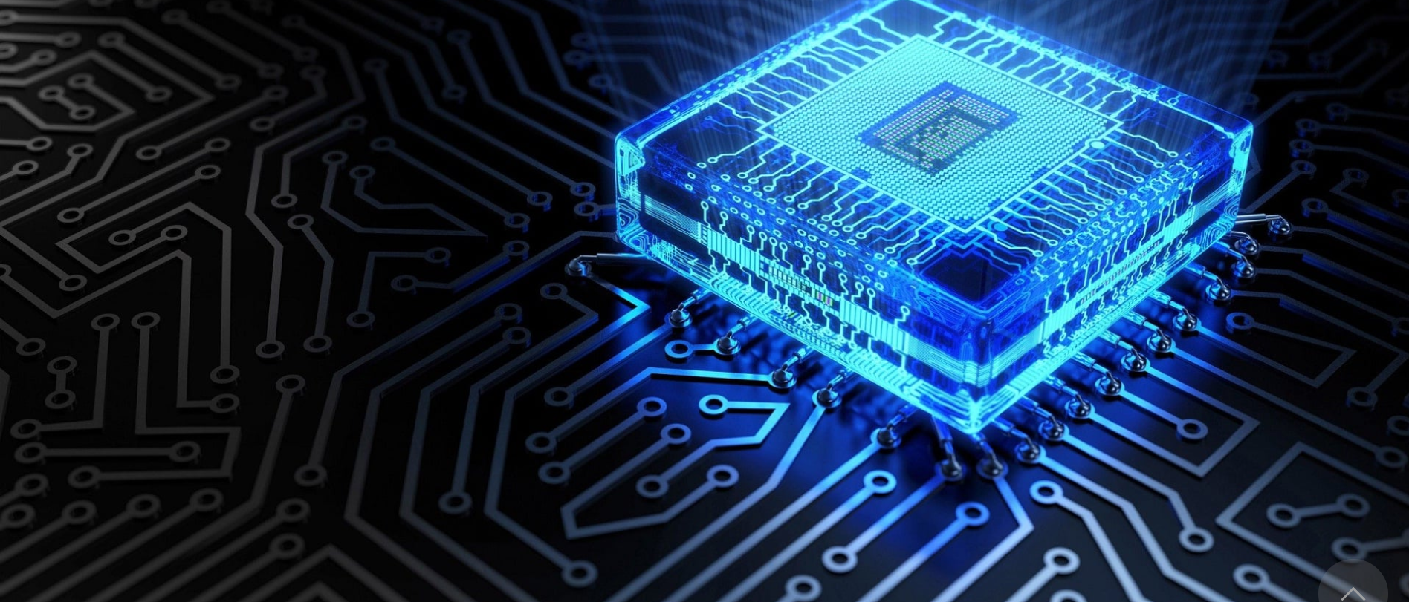**Final Project BBQM**

**Team Members: -**

1. **Ahmed Nasser Emam Ibrahim**
2. **Ahmed Mohamed Mahmoud Taha**
3. **Adham Ibrahim**

**Supervisors: -**

**Dr. Ahmed Shalaby**

**Eng. Mostafa Samy**

# Contents

Contents 2

• Inputs 3

• Outputs 3

• Truth table 4

• BBqM C++ Code 5

1) Flags Function 5

2) UpDown_Counter Function 6

3) Setting_Tcount Function 7

4) Setting_Pcount Function 7

5) Wtime_Calculations Function 8

6) Display Function 9

7) Menu Function 9

8) Main Function 10

• Wtime Calculations Assembly code 11

• Wtime Calculations Machine code 12

o MIPS Register Set 12

o Instruction Formats 12

o MIPS Instructions 13

o Converting Assembly to Machine code 13

o Machine code && Assembly 18

• Executable File Header 19

• Memory 20

• Testcases with Their testbenches 21

o Single Cycle Processor 21

o Single Cycle Control 22

o ALU 22

o Case 1 At Tcount = 1, Pcount = 7 Expected Wtime = 21 23

o Case 2 At Tcount = 1, Pcount = 7 Expected Wtime = 3 28

* Inputs

|  |  |
| --- | --- |
| **Inputs** | **Description** |
| **Tcount** | Describes the number of available tellers |
| **Reset** | Used to reset system |
| **UpDown** | When it equals “1” it pushes up the queue of system  When it equals “0” it pushes down the queue of system |

* Outputs

|  |  |
| --- | --- |
| **Outputs** | Description |
| **Pcount** | Describes the number of people in the queue |
| **Wtime** | Describes the waiting time of people in the queue |
| **Full** | Show if the queue is full or not |
| **Empty** | Show if the queue is empty or not |
| **Alarm** | When pushing up while queue is full or  When pushing down while queue is empty it becomes “1” |
| **Error** | Show the error happened during the run of the system |

* Truth table 

|  |  |  |  |  |  |  |
| --- | --- | --- | --- | --- | --- | --- |
| **Tcount** | **Pcount** | **UpDown** | **Wtime** | **Empty** | **Full** | **Alarm** |
| 0 | 0 | X | 0 | 1 | 0 | 1 |
| 1 | 0 | 0 | 0 | 1 | 0 | 1 |
| 1 | 0 | 1 | 0 | 1 | 0 | 0 |
| 1 | 1 | X | 3 | 0 | 0 | 0 |
| 1 | 2 | X | 6 | 0 | 0 | 0 |
| 1 | 3 | X | 9 | 0 | 0 | 0 |
| 1 | 4 | X | 12 | 0 | 0 | 0 |
| 1 | 5 | X | 15 | 0 | 0 | 0 |
| 1 | 6 | X | 18 | 0 | 0 | 0 |
| 1 | 7 | 0 | 21 | 0 | 1 | 0 |
| 1 | 7 | 1 | 21 | 0 | 1 | 1 |
| 2 | 0 | 0 | 0 | 1 | 0 | 1 |
| 2 | 0 | 1 | 0 | 1 | 0 | 0 |
| 2 | 1 | X | 3 | 0 | 0 | 0 |
| 2 | 2 | X | 4 | 0 | 0 | 0 |
| 2 | 3 | X | 6 | 0 | 0 | 0 |
| 2 | 4 | X | 7 | 0 | 0 | 0 |
| 2 | 5 | X | 9 | 0 | 0 | 0 |
| 2 | 6 | X | 10 | 0 | 0 | 0 |
| 2 | 7 | 0 | 12 | 0 | 1 | 0 |
| 2 | 7 | 1 | 12 | 0 | 1 | 1 |
| 3 | 0 | 0 | 0 | 1 | 0 | 1 |
| 3 | 0 | 1 | 0 | 1 | 0 | 0 |
| 3 | 1 | X | 3 | 0 | 0 | 0 |
| 3 | 2 | X | 4 | 0 | 0 | 0 |
| 3 | 3 | X | 5 | 0 | 0 | 0 |
| 3 | 4 | X | 6 | 0 | 0 | 0 |
| 3 | 5 | X | 7 | 0 | 0 | 0 |
| 3 | 6 | X | 8 | 0 | 0 | 0 |
| 3 | 7 | 0 | 9 | 0 | 1 | 0 |
| 3 | 7 | 1 | 9 | 0 | 1 | 1 |

* BBqM C++ Code

1. 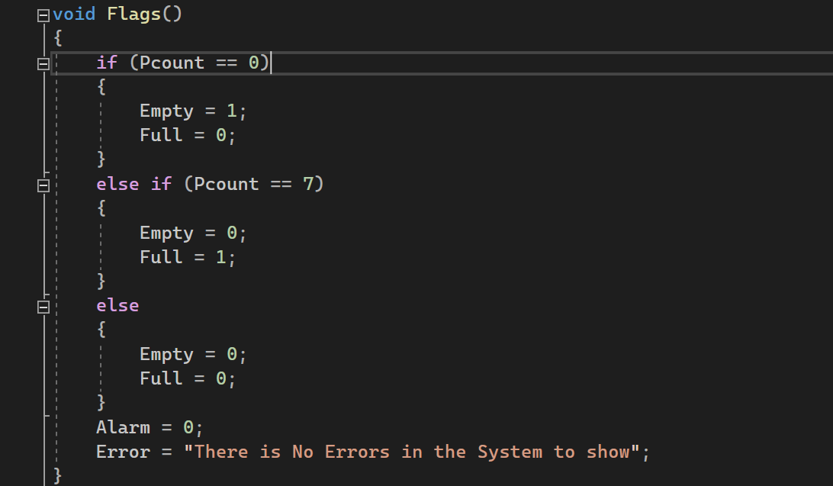Flags Function

**Description**: it used to set the values of Empty, Full, Alarm and Error according to the change in value of Pcount.

Empty: describe if Pcount reaches the minimum number or not

Full: describe if Pcount reaches the maximum number or not

Alarm: describe if error happened to the system or not

Error: show the error happened during execution

1. 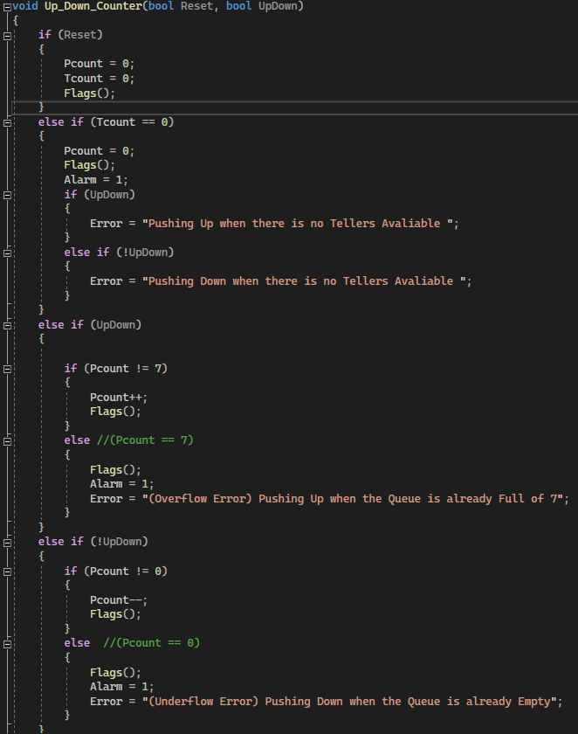UpDown_Counter Function

**Description:** it takes Reset and UpDown as arguments and used them to reset the system, push up or push down the system, here we call Flags function due to there is the change in Pcount Happened and describe the error happened.

1. 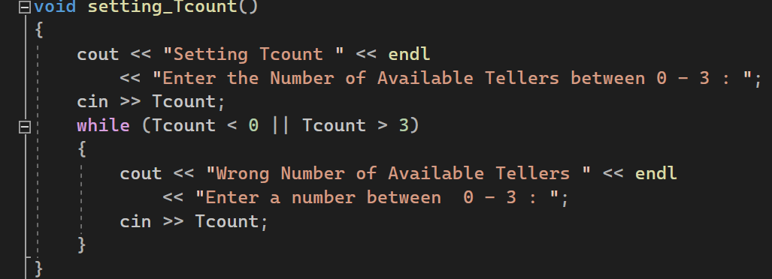Setting_Tcount Function

**Description:** it used to set the value of Tcount and avoid choosing value < 0 Tellers and > 3 Tellers

1. 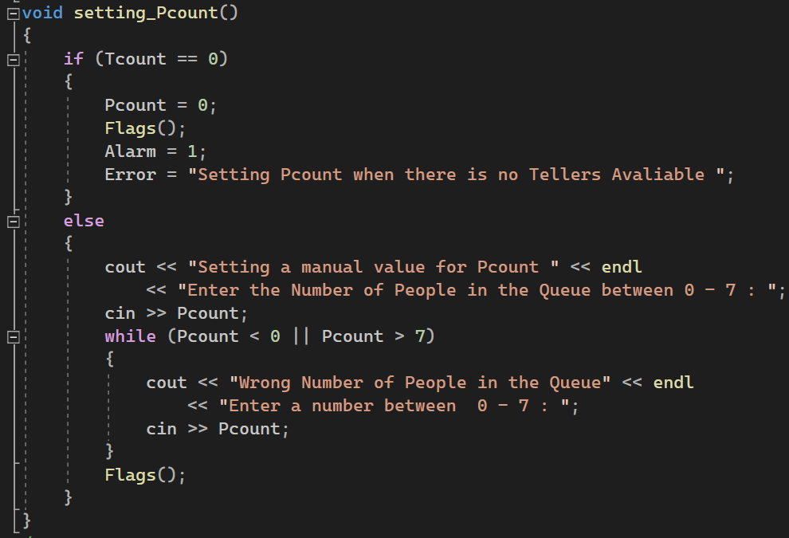Setting_Pcount Function

**Description:** it used to set the value of Pcount and avoid choosing value < 0 Persons and > 7 Persons

Due to changing value of Pcount we call Flag Function

When tellers are not available so no service then Pcount becomes 0.

1. Wtime_Calculations Function

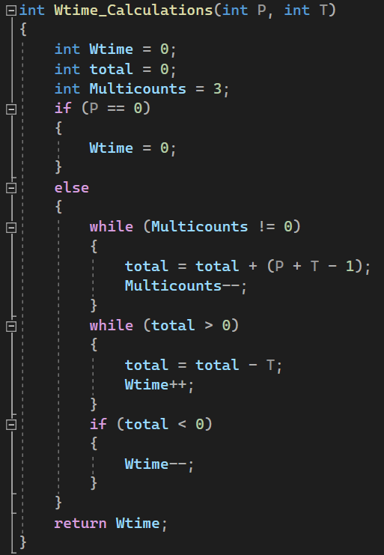

**Description:** it used to calculate the value of Wtime according to the arguments (Pcount, Tcount) and to the law

Wtime (Pcount = 0) = 0,Wtime (Pcount ≠ 0, Tcount) = 3*(Pcount+Tcount-1)/Tcount

But this Function later we will assemble (Changing to MIPS Assembly), and we don’t have the needed instructions (mult, div) on the single cycle MIPS processor that we have.

So, we solve the problem by using the concepts of Multiplications is the process of repeating addition and

Division is the process of repeating subtraction.

1. 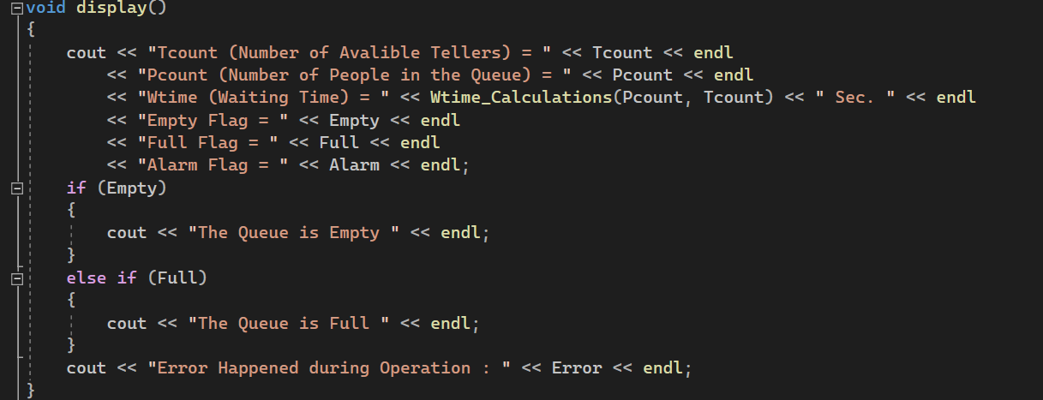Display Function

**Description:** it used to show all data we have in the system values of Tcount, Pcount, Wtime, Empty, Full, Alarm, Error.

1. Menu Function

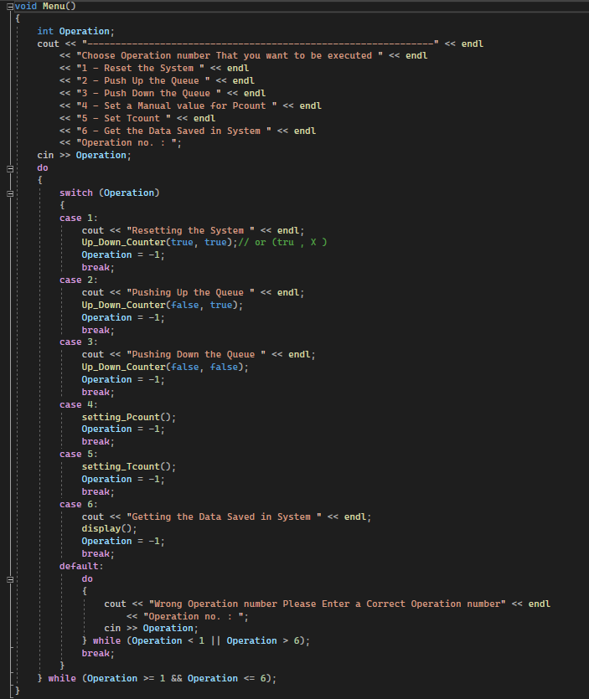

**Description:** it used to make a menu of operation the user can choose from it to handle the system; it asks the user to choose operation number then execute it.

Operations are

* + 1. Reset the System
    2. Push Up the Queue
    3. Push Down the Queue
    4. Set a Manual value for Pcount
    5. Set Tcount
    6. Get the Data Saved in System

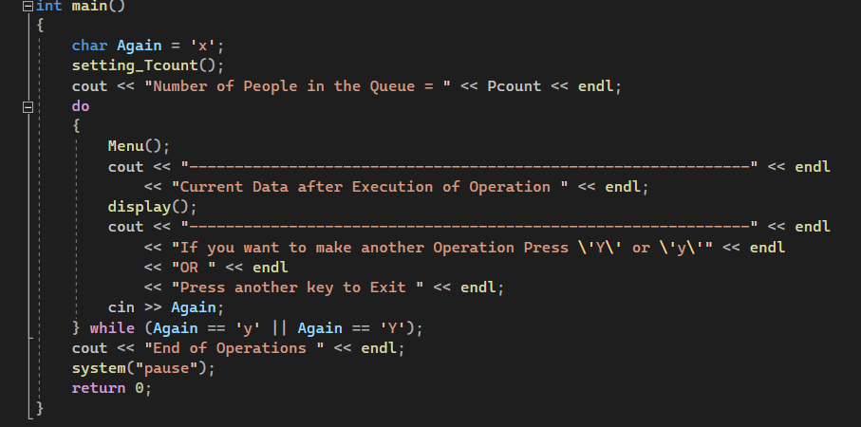After choosing the operation number it executes it using the calling of all previous Functions.

1. Main Function

**Description:** it’s the function here all functions are called there by calling Menu function and choosing the operation

Then ask the user if he want another operation or not.

* 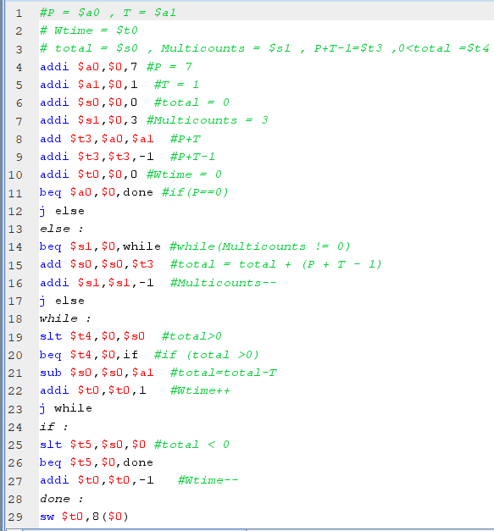Wtime Calculations Assembly code
* Wtime Calculations Machine code
  + 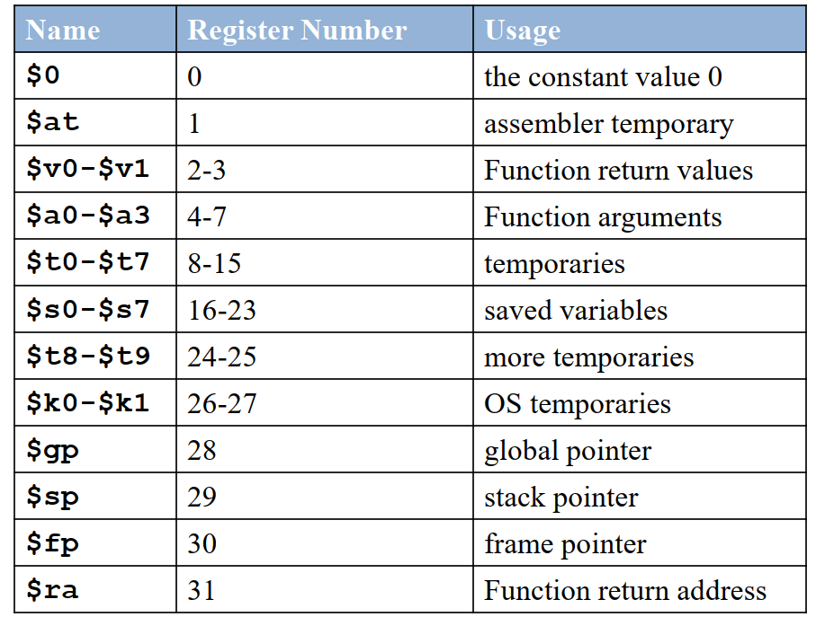MIPS Register Set
  + 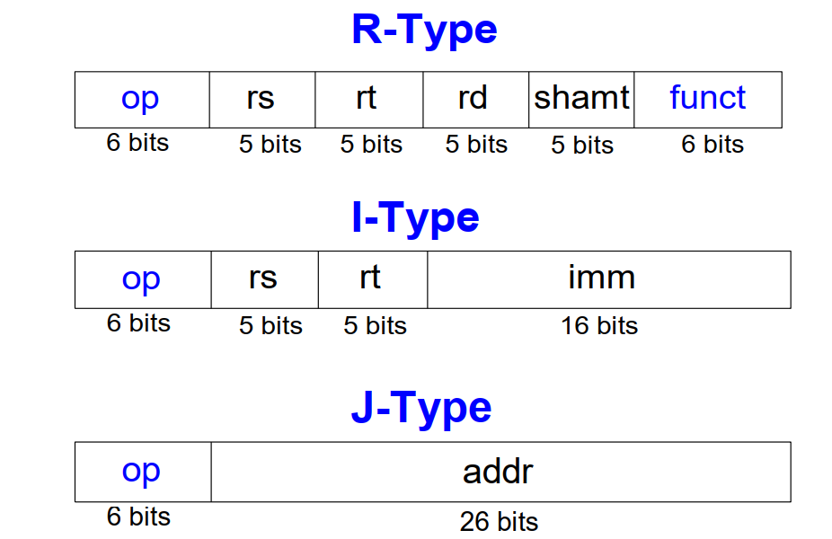Instruction Formats
  + MIPS Instructions

**R-Type Instructions**

|  |  |  |  |
| --- | --- | --- | --- |
| Funct | Name | Description | Operation |
| 100000 (32) | add rd, rs, rt | add | [rd] = [rs] + [rt] |
| 100010 (34) | sub rd, rs, rt | subtract | [rd] = [rs] – [rt] |
| 101010 (42) | slt rd, rs, rt | set less than | [rs] < [rt] ? [rd] = 1 : [rd] = 0 |

**I-Type Instructions**

|  |  |  |  |
| --- | --- | --- | --- |
| Opcode | Name | Description | Operation |
| 000100 (4) | beq rs, rt, label | branch if equal | if ([rs] == [rt]) PC = BTA |
| 001000 (8) | addi rt, rs, imm | add immediate | [rt] = [rs] + SignImm |
| 101011 (43) | sw rt, imm(rs) | store word | [Address] = [rt] |

**J-Type Instructions**

|  |  |  |  |
| --- | --- | --- | --- |
| Opcode | Name | Description | Operation |
| 000010 (2) | j label | jump | PC = JTA |

* + Converting Assembly to Machine code

1. **addi $a0,$0,7 -> I-Type**

|  |  |  |  |
| --- | --- | --- | --- |
| **8** | **0** | **4** | **7** |

**6 bits 5 bits 5 bits 16 bits**

|  |  |  |  |
| --- | --- | --- | --- |
| **0010 00** | **00 000** | **0 0100** | **0000 0000 0000 0111** |

**Machine code in hexadecimal format-> 0x20040007**

1. **addi $a1,$0,1 -> I-Type**

|  |  |  |  |
| --- | --- | --- | --- |
| **8** | **0** | **5** | **1** |

**6 bits 5 bits 5 bits 16 bits**

|  |  |  |  |
| --- | --- | --- | --- |
| **0010 00** | **00 000** | **0 0101** | **0000 0000 0000 0001** |

**Machine code in hexadecimal format-> 0x20050001**

1. **addi $s0,$0,0 ->I-Type**

|  |  |  |  |
| --- | --- | --- | --- |
| **8** | **0** | **16** | **0** |

**6 bits 5 bits 5 bits 16 bits**

|  |  |  |  |
| --- | --- | --- | --- |
| **0010 00** | **00 000** | **1 0000** | **0000 0000 0000 0000** |

**Machine code in hexadecimal format-> 0x20100000**

1. **addi $s1,$0,3 -> I-Type**

|  |  |  |  |
| --- | --- | --- | --- |
| **8** | **0** | **17** | **3** |

**6 bits 5 bits 5 bits 16 bits**

|  |  |  |  |
| --- | --- | --- | --- |
| **0010 00** | **00 000** | **1 0001** | **0000 0000 0000 0011** |

**Machine code in hexadecimal format-> 0x20110003**

1. **add $t3,$a0,$a1 -> R-Type**

|  |  |  |  |  |  |
| --- | --- | --- | --- | --- | --- |
| **0** | **4** | **5** | **11** | **0** | **32** |

**6 bits 5 bits 5 bits 5 bits 5 bits 6 bits**

|  |  |  |  |  |  |
| --- | --- | --- | --- | --- | --- |
| **0000 00** | **00 100** | **0 0101** | **0101 1** | **000 00** | **10 0000** |

**Machine code in hexadecimal format-> 0x00855820**

1. **addi $t3,$t3,-1 -> I-Type**

|  |  |  |  |
| --- | --- | --- | --- |
| **8** | **11** | **11** | **-1** |

**6 bits 5 bits 5 bits 16 bits**

|  |  |  |  |
| --- | --- | --- | --- |
| **0010 00** | **01 011** | **0 1011** | **1111 1111 1111 1111** |

**Machine code in hexadecimal format-> 0x216BFFFF**

1. **addi $t0,$0,0 -> I-Type**

|  |  |  |  |
| --- | --- | --- | --- |
| **8** | **0** | **8** | **0** |

**6 bits 5 bits 5 bits 16 bits**

|  |  |  |  |
| --- | --- | --- | --- |
| **0010 00** | **00 000** | **0 1000** | **0000 0000 0000 0000** |

**Machine code in hexadecimal format-> 0x20080000**

1. **beq $a0,$0,done -> I-Type**

|  |  |  |  |
| --- | --- | --- | --- |
| **4** | **4** | **0** | **13** |

**6 bits 5 bits 5 bits 16 bits**

|  |  |  |  |
| --- | --- | --- | --- |
| **0001 00** | **00 100** | **0 0000** | **0000 0000 0000 1101** |

**Machine code in hexadecimal format-> 0x1080000D**

1. **j else -> J-Type**

|  |  |
| --- | --- |
| **2** | **Address = 0x00400024** |

**6 bits 26 bits**

|  |  |
| --- | --- |
| **0000 10** | **00 0001 0000 0000 0000 0000 1001** |

**Machine code in hexadecimal format-> 0x08100009**

1. **else: beq $s1,$0,while -> I-Type**

|  |  |  |  |
| --- | --- | --- | --- |
| **4** | **17** | **0** | **3** |

**6 bits 5 bits 5 bits 16 bits**

|  |  |  |  |
| --- | --- | --- | --- |
| **0001 00** | **10 001** | **0 0000** | **0000 0000 0000 0011** |

**Machine code in hexadecimal format-> 0x12200003**

1. **add $s0,$s0,$t3 -> R-Type**

|  |  |  |  |  |  |
| --- | --- | --- | --- | --- | --- |
| **0** | **16** | **11** | **16** | **0** | **32** |

**6 bits 5 bits 5 bits 5 bits 5 bits 6 bits**

|  |  |  |  |  |  |
| --- | --- | --- | --- | --- | --- |
| **0000 00** | **10 000** | **0 1011** | **1000 0** | **000 00** | **10 0000** |

**Machine code in hexadecimal format-> 0x020B8020**

1. **addi $s1,$s1,-1 -> I-Type**

|  |  |  |  |
| --- | --- | --- | --- |
| **8** | **17** | **17** | **-1** |

**6 bits 5 bits 5 bits 16 bits**

|  |  |  |  |
| --- | --- | --- | --- |
| **0010 00** | **10 001** | **1 0001** | **1111 1111 1111 1111** |

**Machine code in hexadecimal format-> 0x2231FFFF**

1. **j else -> J-Type**

|  |  |
| --- | --- |
| **2** | **Address = 0x00400024** |

**6 bits 26 bits**

|  |  |
| --- | --- |
| **0000 10** | **00 0001 0000 0000 0000 0000 1001** |

**Machine code in hexadecimal format-> 0x08100009**

1. **while: slt $t4,$0,$s0 -> R-Type**

|  |  |  |  |  |  |
| --- | --- | --- | --- | --- | --- |
| **0** | **0** | **16** | **12** | **0** | **42** |

**6 bits 5 bits 5 bits 5 bits 5 bits 6 bits**

|  |  |  |  |  |  |
| --- | --- | --- | --- | --- | --- |
| **0000 00** | **00 000** | **1 0000** | **0110 0** | **000 00** | **10 1010** |

**Machine code in hexadecimal format-> 0x0010602A**

1. **beq $t4,$0,if -> I-Type**

|  |  |  |  |
| --- | --- | --- | --- |
| **4** | **12** | **0** | **3** |

**6 bits 5 bits 5 bits 16 bits**

|  |  |  |  |
| --- | --- | --- | --- |
| **0001 00** | **01 100** | **0 0000** | **0000 0000 0000 0011** |

**Machine code in hexadecimal format-> 0x11800003**

1. **sub $s0,$s0,$a1 -> R-Type**

|  |  |  |  |  |  |
| --- | --- | --- | --- | --- | --- |
| **0** | **16** | **5** | **16** | **0** | **34** |

**6 bits 5 bits 5 bits 5 bits 5 bits 6 bits**

|  |  |  |  |  |  |
| --- | --- | --- | --- | --- | --- |
| **0000 00** | **10 000** | **0 0101** | **1000 0** | **000 00** | **10 0010** |

**Machine code in hexadecimal format-> 0x02058022**

1. **addi $t0,$t0,1 -> I-Type**

|  |  |  |  |
| --- | --- | --- | --- |
| **8** | **8** | **8** | **1** |

**6 bits 5 bits 5 bits 16 bits**

|  |  |  |  |
| --- | --- | --- | --- |
| **0010 00** | **01 000** | **0 1000** | **0000 0000 0000 0001** |

**Machine code in hexadecimal format-> 0x21080001**

1. **j while -> J-Type**

|  |  |
| --- | --- |
| **2** | **Address = 0x00400034** |

**6 bits 26 bits**

|  |  |
| --- | --- |
| **0000 10** | **00 0001 0000 0000 0000 0000 1101** |

**Machine code in hexadecimal format-> 0x0810000D**

1. **if: slt $t5,$s0,$0 -> R-Type**

|  |  |  |  |  |  |
| --- | --- | --- | --- | --- | --- |
| **0** | **16** | **0** | **13** | **0** | **42** |

**6 bits 5 bits 5 bits 5 bits 5 bits 6 bits**

|  |  |  |  |  |  |
| --- | --- | --- | --- | --- | --- |
| **0000 00** | **10 000** | **0 0000** | **0110 1** | **000 00** | **10 1010** |

**Machine code in hexadecimal format-> 0x0200682A**

1. **beq $t5,$0,done -> I-Type**

|  |  |  |  |
| --- | --- | --- | --- |
| **4** | **13** | **0** | **1** |

**6 bits 5 bits 5 bits 16 bits**

|  |  |  |  |
| --- | --- | --- | --- |
| **0001 00** | **01 101** | **0 0000** | **0000 0000 0000 0001** |

**Machine code in hexadecimal format-> 0x11A00001**

1. **addi $t0,$t0,-1 -> I-Type**

|  |  |  |  |
| --- | --- | --- | --- |
| **8** | **8** | **8** | **1** |

**6 bits 5 bits 5 bits 16 bits**

|  |  |  |  |
| --- | --- | --- | --- |
| **0010 00** | **01 000** | **0 1000** | **1111 1111 1111 1111** |

**Machine code in hexadecimal format-> 0x2108FFFF**

1. **done: sw $t0,8($0)**

|  |  |  |  |
| --- | --- | --- | --- |
| **43** | **8** | **8** | **8** |

**6 bits 5 bits 5 bits 16 bits**

|  |  |  |  |
| --- | --- | --- | --- |
| **1010 11** | **00 000** | **0 1000** | **0000 0000 0000 1000** |

**Machine code in hexadecimal format-> 0xAC080008**

|  |  |  |  |
| --- | --- | --- | --- |
| **Address** | **Machine** | **Assembly** | **Description** |
| **0x00400000**  **0x00400004**  **0x00400008**  **0x0040000c**  **0x00400010**  **0x00400014**  **0x00400018**  **0x0040001c**  **0x00400020**  **0x00400024**  **0x00400028**  **0x0040002c**  **0x00400030**  **0x00400034**  **0x00400038**  **0x0040003c**  **0x00400040**  **0x00400044**  **0x00400048**  **0x0040004c**  **0x00400050**  **0x00400054** | **0x20040007**  **0x20050001**  **0x20100000**  **0x20110003**  **0x00855820**  **0x216BFFFF**  **0x20080000**  **0x1080000D**  **0x08100009**  **0x12200003**  **0x020B8020**  **0x2231FFFF**  **0x08100009**  **0x0010602A**  **0x11800003**  **0x02058022**  **0x21080001**  **0x0810000D**  **0x0200682A**  **0x11A00001**  **0x2108FFFF**  **0xAC080008** | **addi $a0,$0,7**  **addi $a1,$0,1**  **addi $s0,$0,0**  **addi $s1,$0,3**  **add $t3,$a0,$a1**  **addi $t3,$t3,-1**  **addi $t0,$0,0**  **beq $a0,$0,done**  **j else**  **else: beq $s1,$0,while**  **add $s0,$s0,$t3**  **addi $s1,$s1,-1**  **j else**  **while: slt $t4,$0,$s0**  **beq $t4,$0,if**  **sub $s0,$s0,$a1**  **addi $t0,$t0,1**  **j while**  **if: slt $t5,$s0,$0**  **beq $t5,$0,done**  **addi $t0,$t0,-1**  **done: sw $t0,8($0)** | **#P = 7**  **#T = 1**  **#total = 0**  **#Multicounts = 3**  **#P+T**  **#P+T-1**  **#Wtime = 0**  **#if(P==0)**  **#while(Multicounts != 0)**  **#total = total + (P + T - 1)**  **#Multicounts—**  **#total>0**  **#if (total >0)**  **#total=total-T**  **#Wtime++**  **#total < 0**  **#if (total <0)**  **#Wtime—**  **#return Wtime (By writing it in Memory)** |

* + Machine code && Assembly
* Executable File Header

|  |  |  |
| --- | --- | --- |
| **Executable File Header** | **Text Size** | **Data Size** |
|  | **0x58 (88 bytes)** | **0x0(0 bytes)** |
| **Text Segment** | **Address** | **Instruction** |
|  | **0x00400000**  **0x00400004**  **0x00400008**  **0x0040000c**  **0x00400010**  **0x00400014**  **0x00400018**  **0x0040001c**  **0x00400020**  **0x00400024**  **0x00400028**  **0x0040002c**  **0x00400030**  **0x00400034**  **0x00400038**  **0x0040003c**  **0x00400040**  **0x00400044**  **0x00400048**  **0x0040004c**  **0x00400050**  **0x00400054** | **0x20040007**  **0x20050001**  **0x20100000**  **0x20110003**  **0x00855820**  **0x216BFFFF**  **0x20080000**  **0x1080000D**  **0x08100009**  **0x12200003**  **0x020B8020**  **0x2231FFFF**  **0x08100009**  **0x0010602A**  **0x11800003**  **0x02058022**  **0x21080001**  **0x0810000D**  **0x0200682A**  **0x11A00001**  **0x2108FFFF**  **0xAC080008** |
| **Data Segment** | **Address** | **Data** |
|  | **-** | **-** |

* Memory

**0x7FFFFFFCC**

**0x10000000**

**0x10010000**

**PC = 0x00400000**

**$sp = 0x7FFFFFFC**

**$gp =0x10080000**

**0x00400000**

|  |
| --- |
| **Reserved** |
| **Stack**  **Heap** |
| **.**  **.**  **.** |
| **.**  **.** |
| **0xAC080008** |
| **0x2108FFFF** |
| **0x11A00001** |
| **0x0200682A** |
| **0x0810000D** |
| **0x21080001** |
| **0x02058022** |
| **0x11800003** |
| **0x0010602A** |
| **0x08100009** |
| **0x2231FFFF** |
| **0x020B8020** |
| **0x12200003** |
| **0x08100009** |
| **0x1080000D** |
| **0x20080000** |
| **0x216BFFFF** |
| **0x00855820** |
| **0x20110003** |
| **0x20100000** |
| **0x20050001** |
| **0x20040007** |
| **Reserved** |

* Testcases with Their testbenches
  + 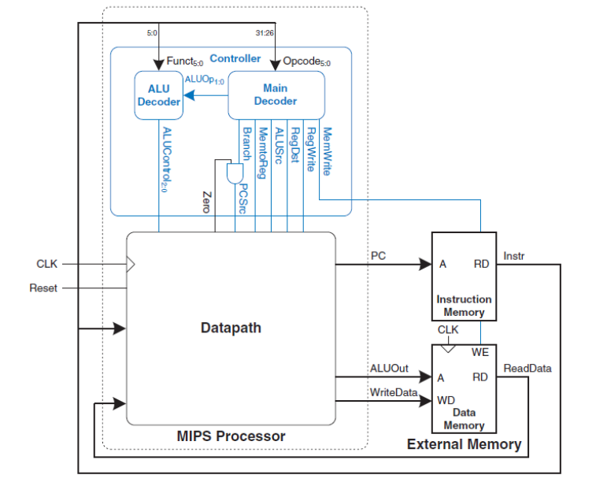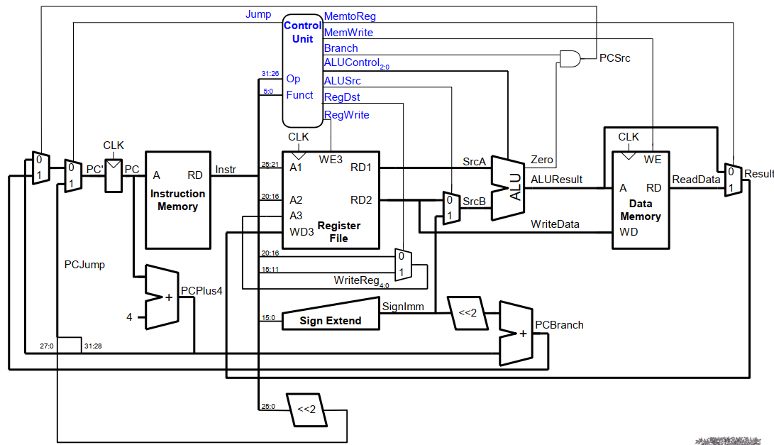Single Cycle Processor
  + 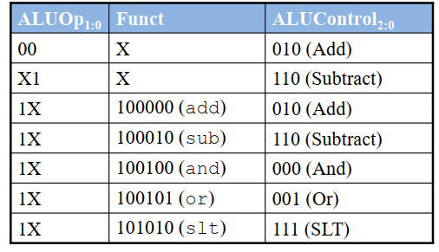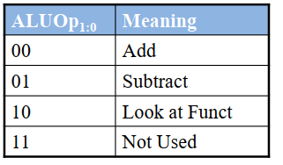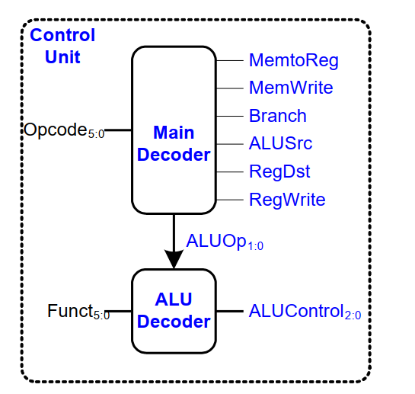Single Cycle Control
  + 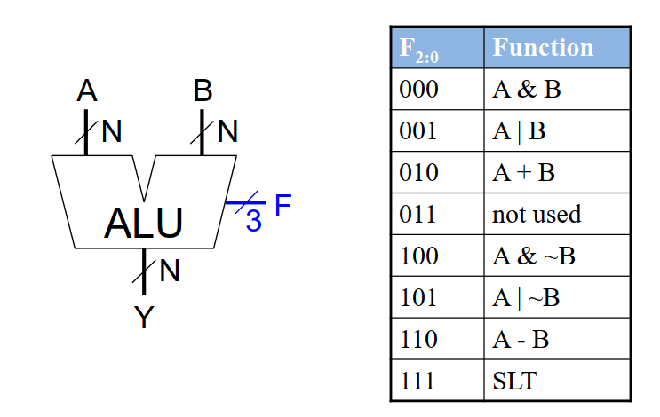ALU



* + 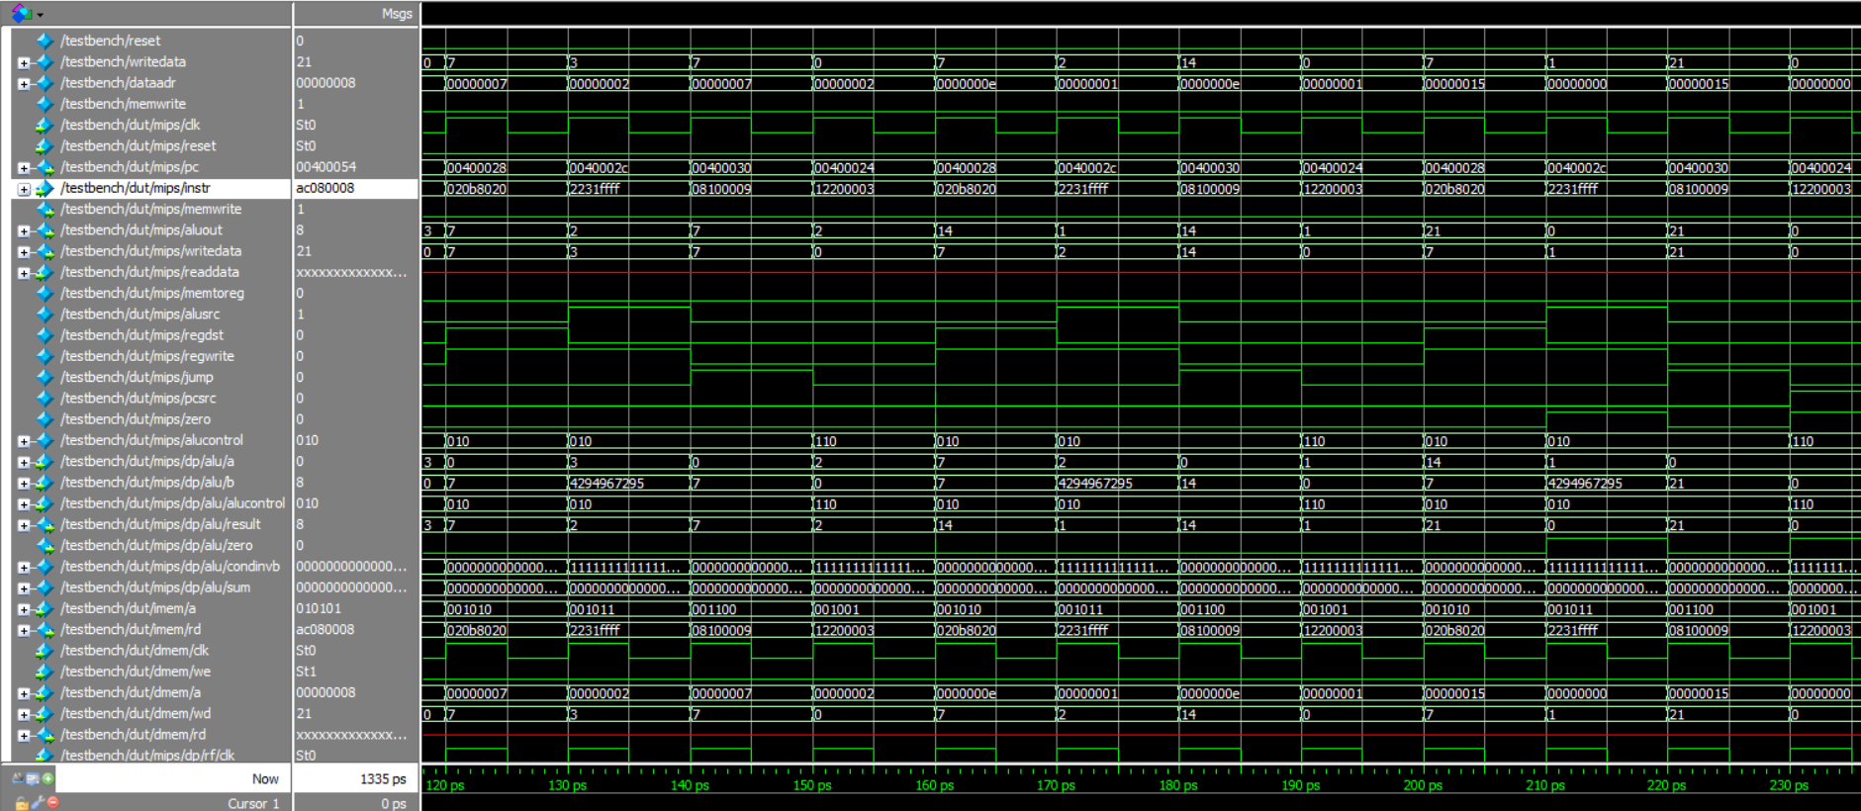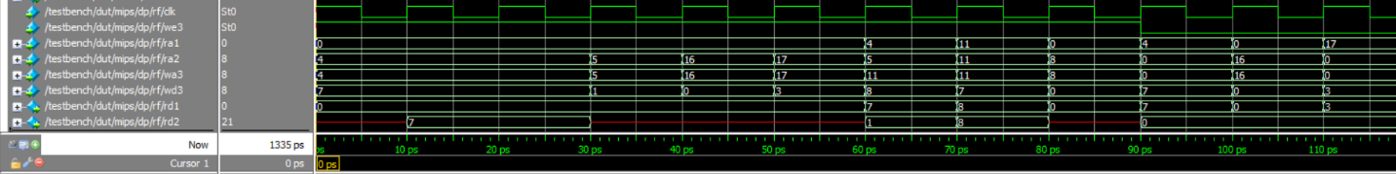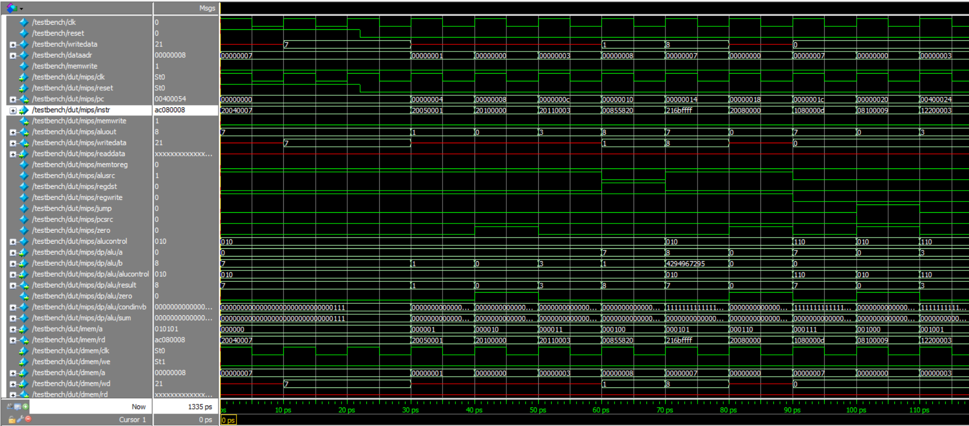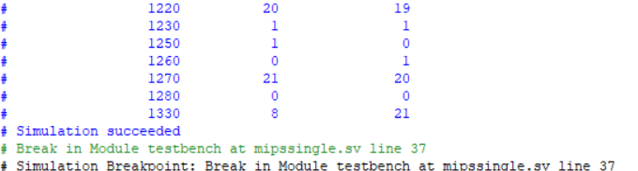Case 1 At Tcount = 1, Pcount = 7 Expected Wtime = 21

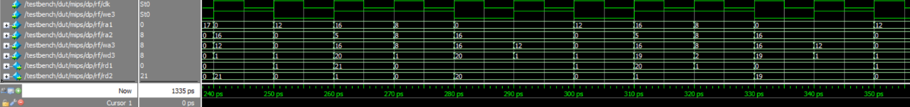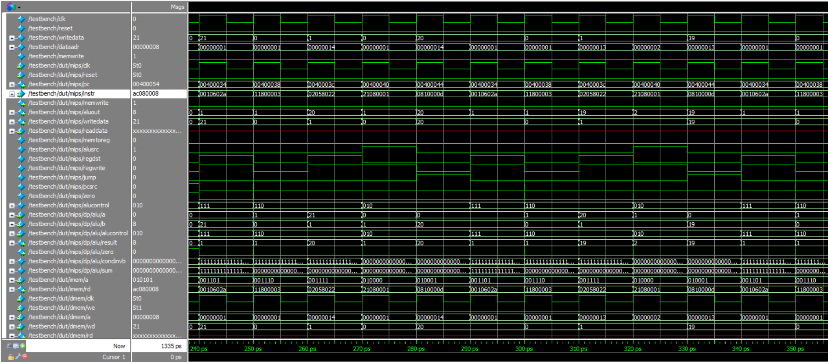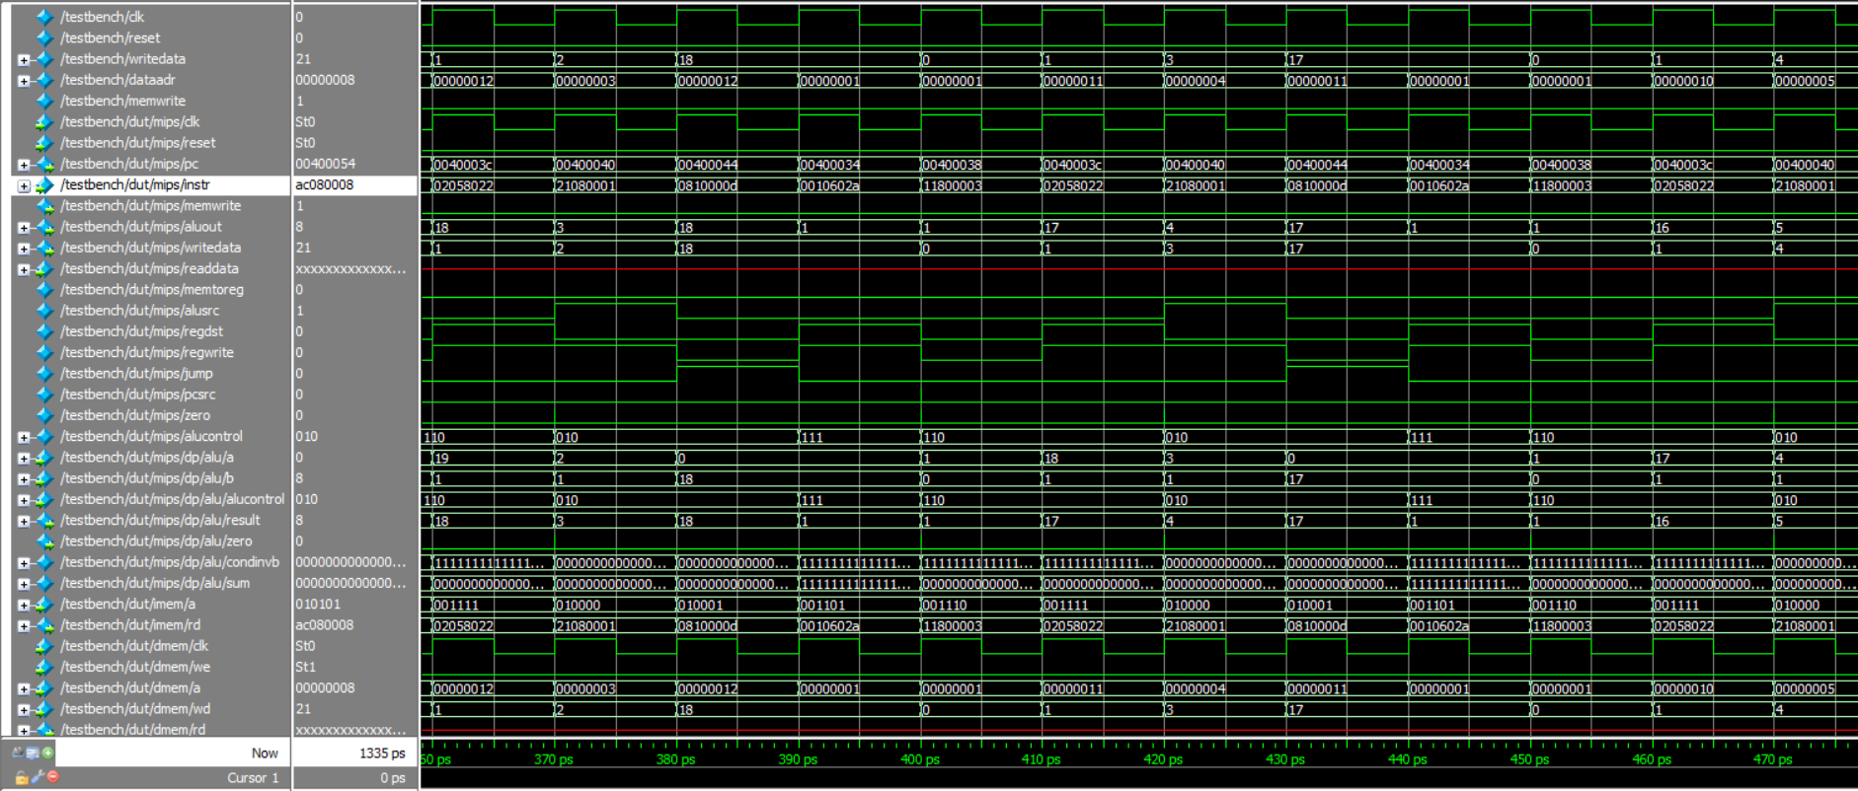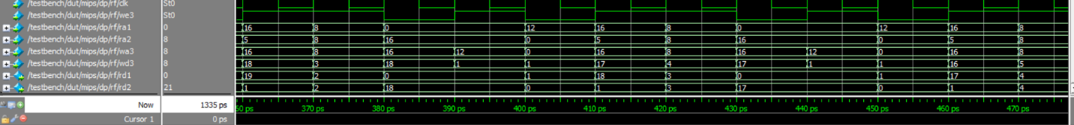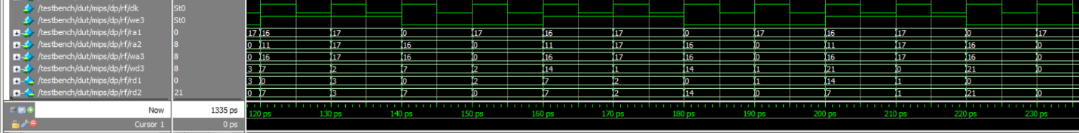

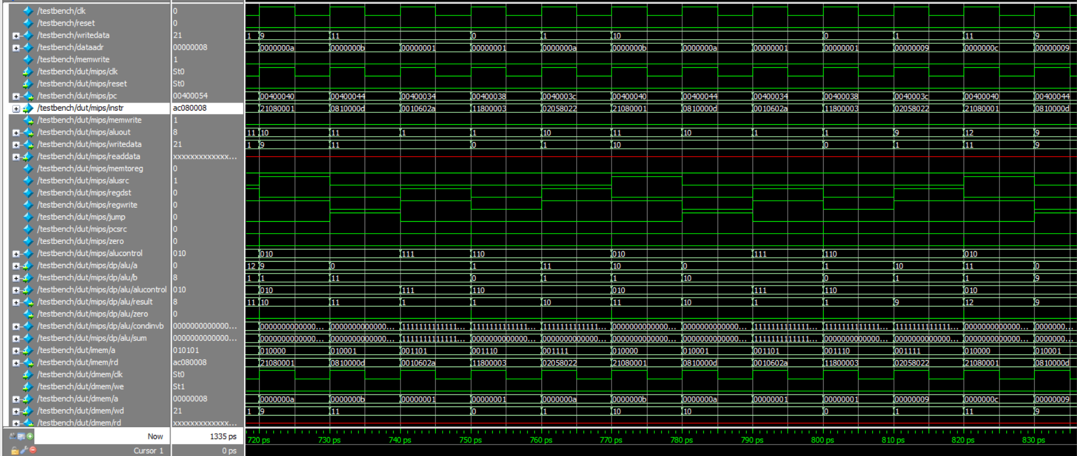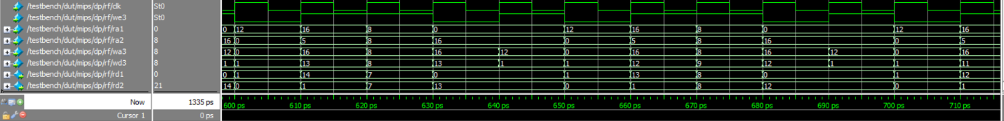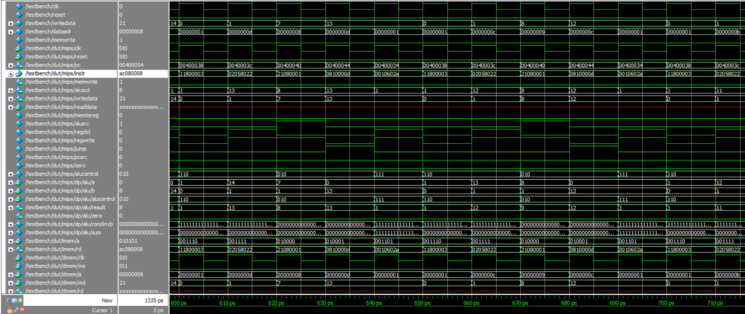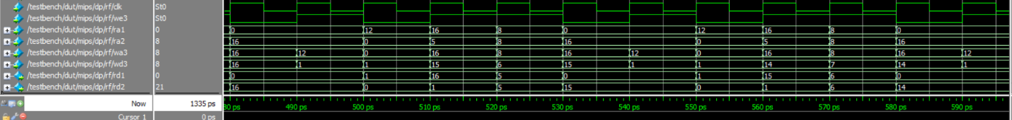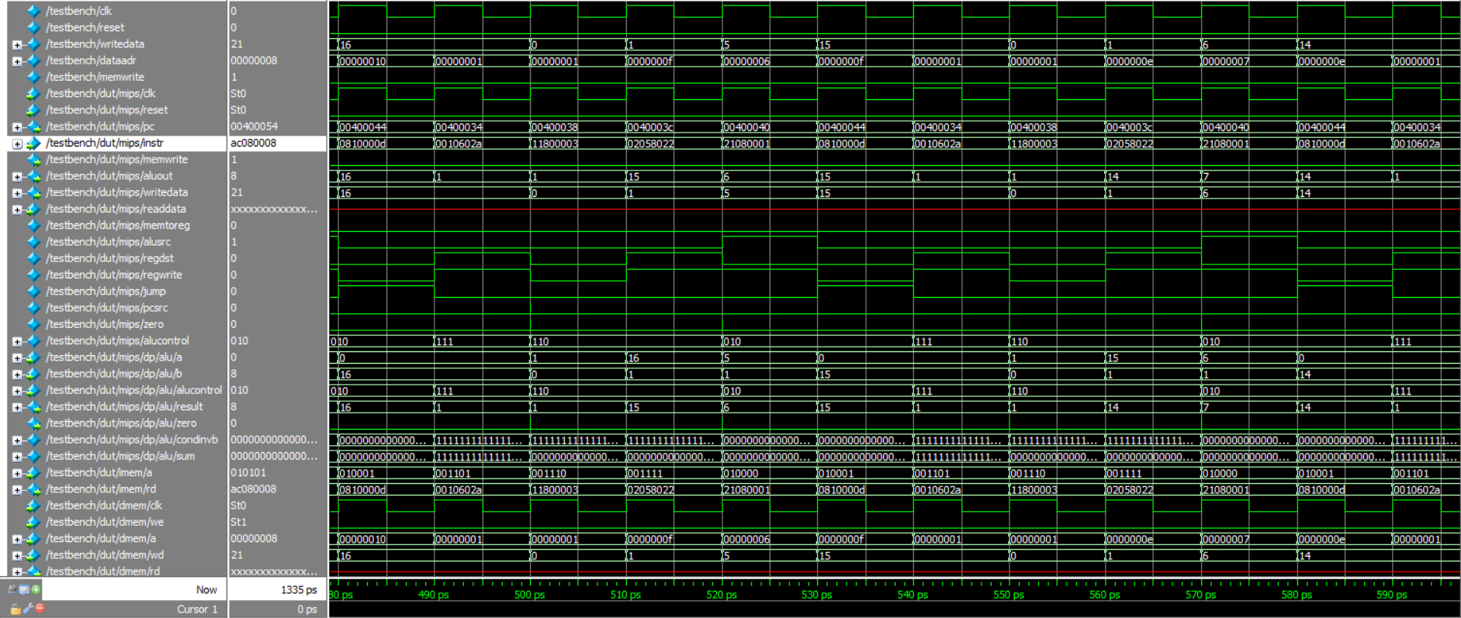

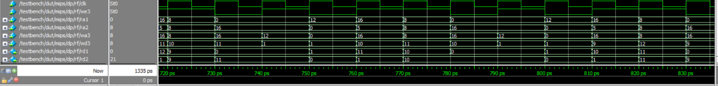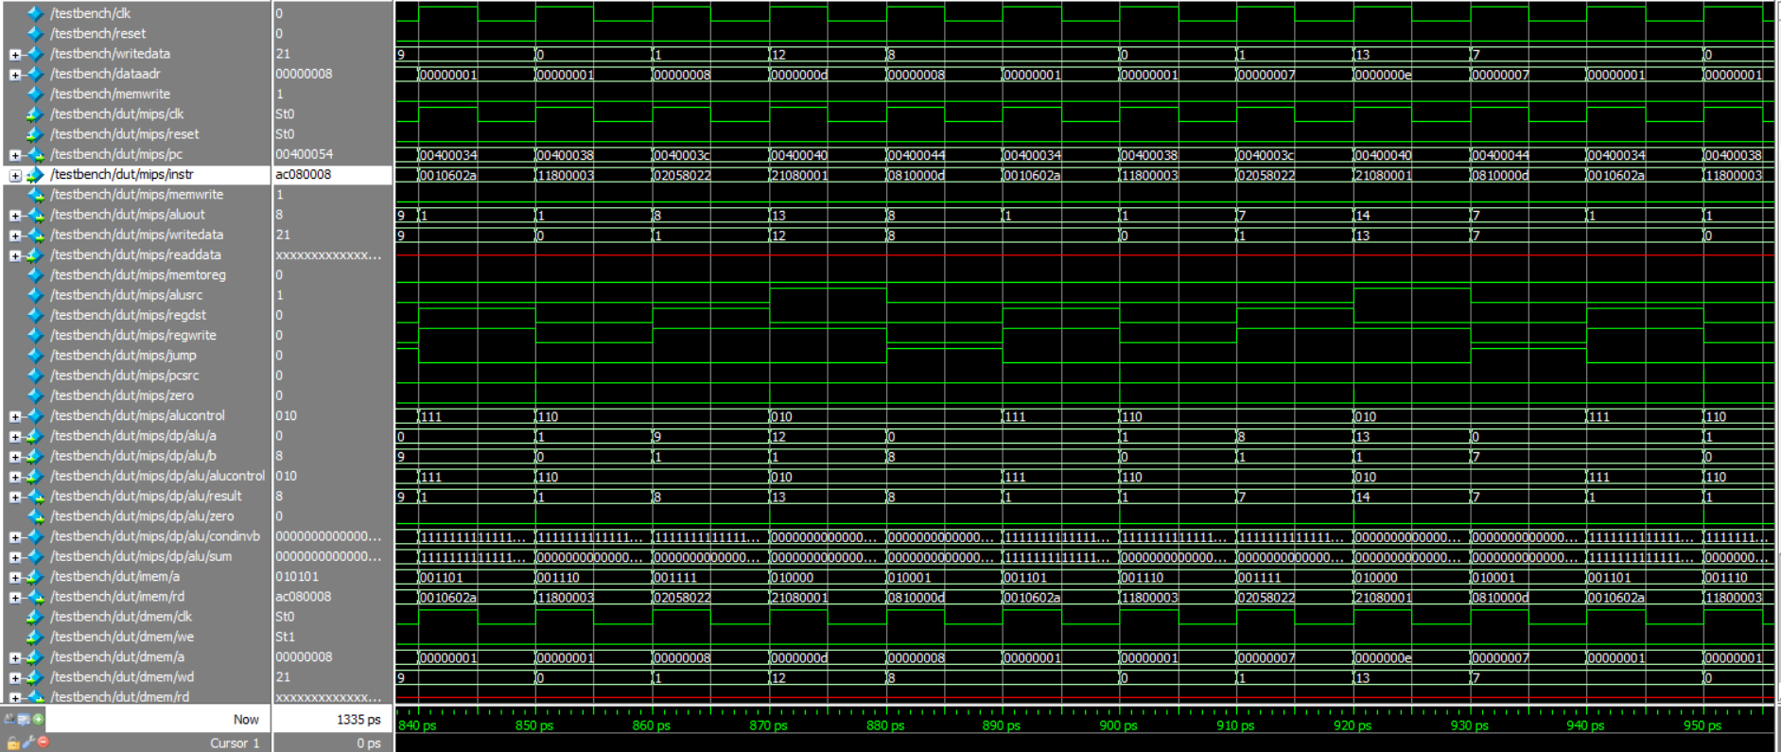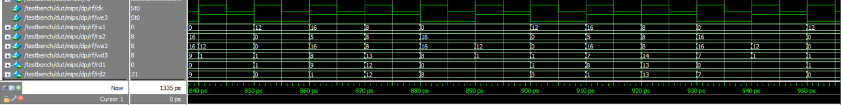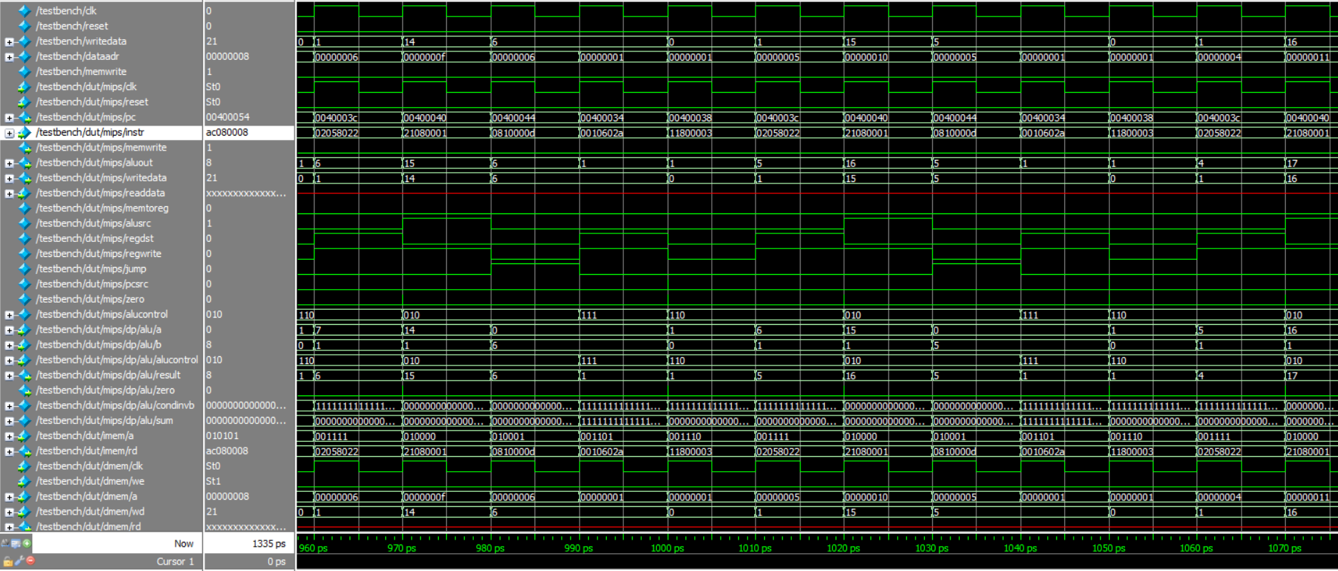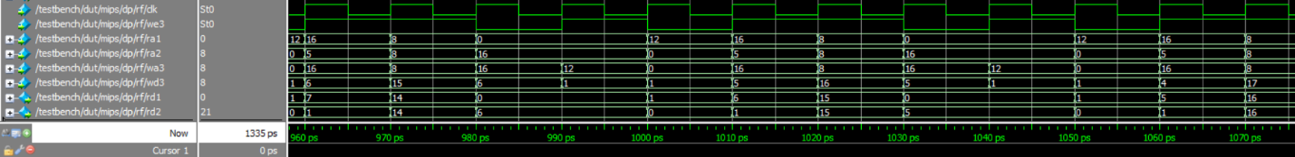

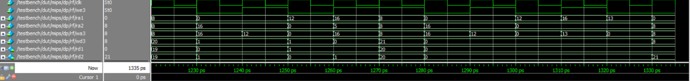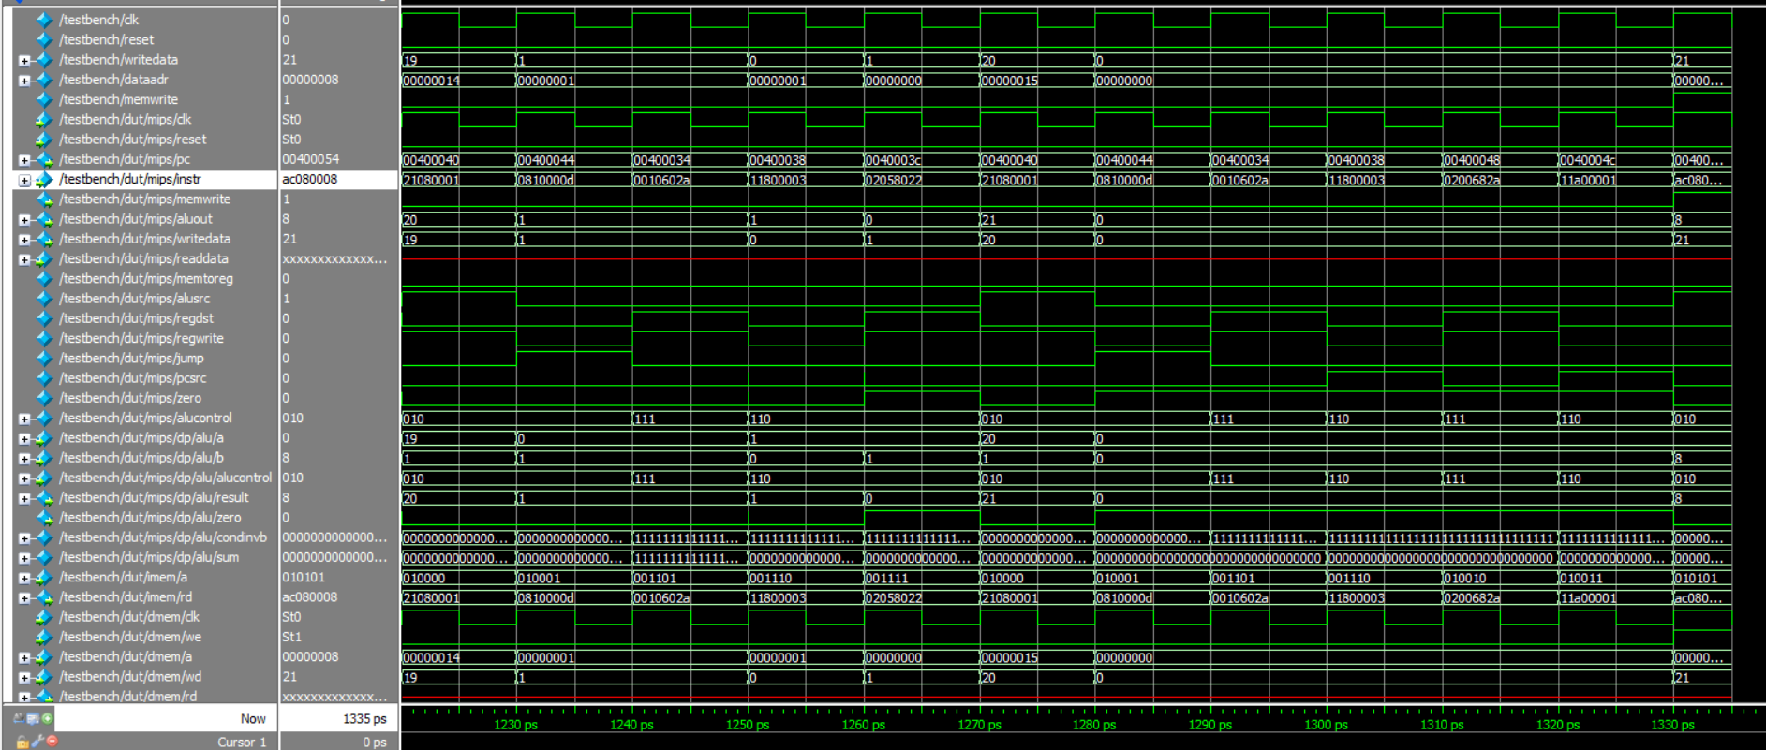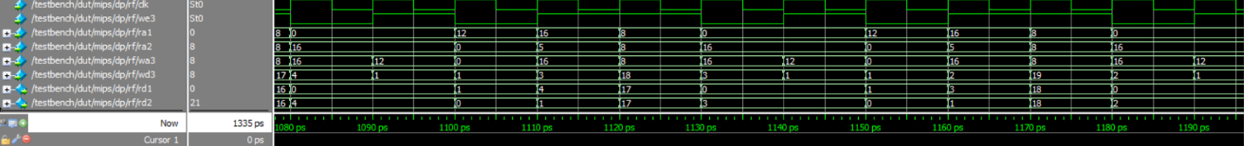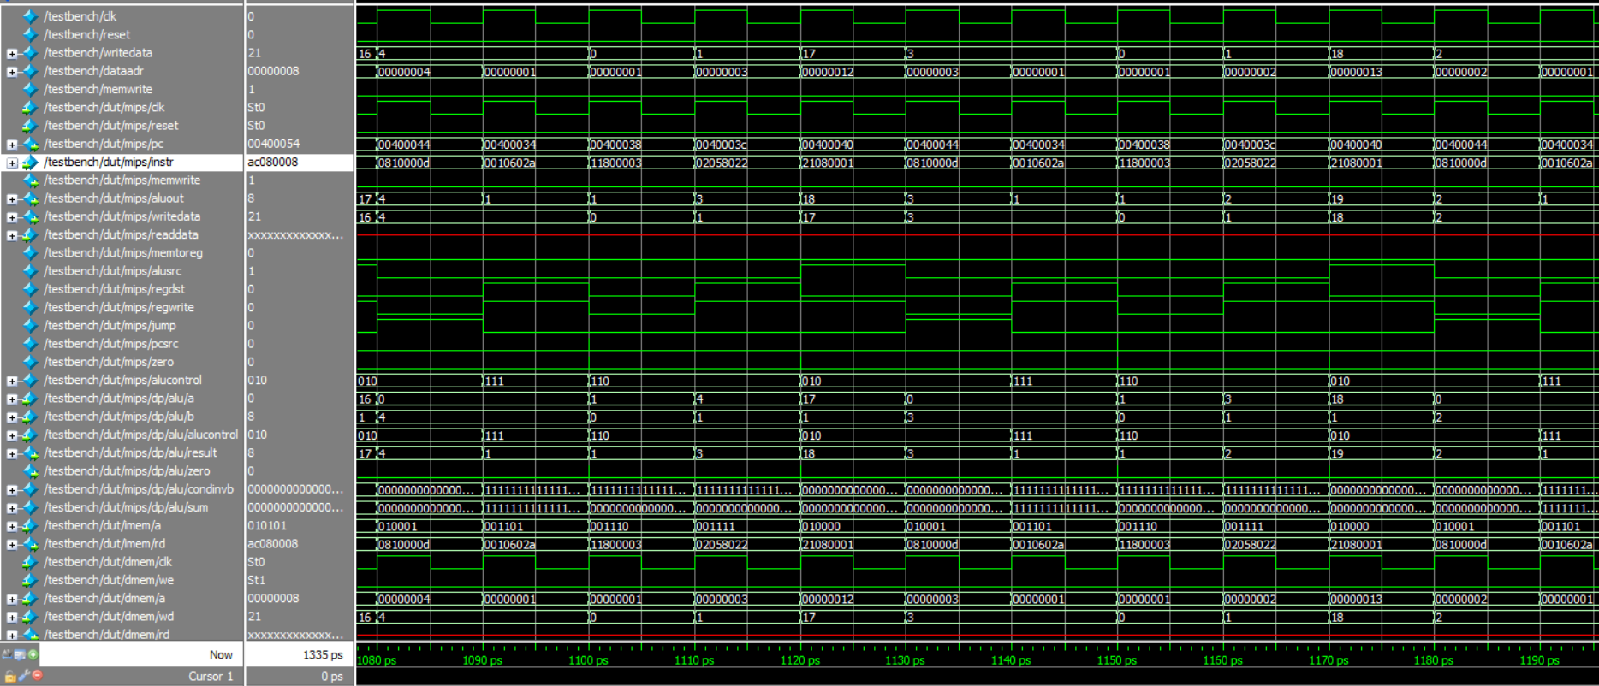

* + 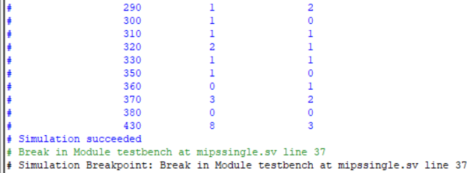Case 2 At Tcount = 1, Pcount = 1 Expected Wtime = 3

